1. When talking about relations, let me show you **one useful operation mongodb** offers for **merging related documents** that you **split up** by using the reference approach so where you got no embedded documents and that is the **lookup operator**.
2. It is used like this.
3. ***Loopup()***: It uses the aggregate method which we have not learned about. We got a whole module about the **aggregation framework** and I don’t want to talk too much about it but lookup is essentially a helpful tool that allows you to fetch two related documents merged together in one document in one step instead of having to do two steps and this mitigates some of the disadvantages across collections because now you can at least merge them in one go.  
   Let me show you how it works.  
   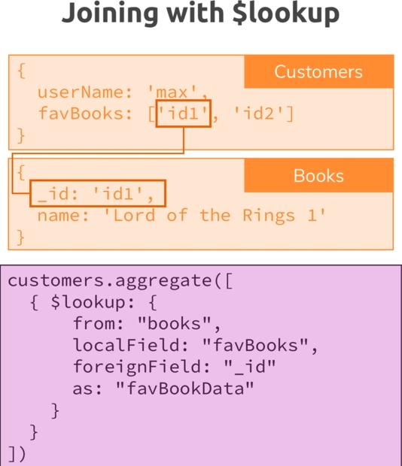ggr
4. Db.books.aggregate([{$lookup:{}}])🡸 Running aggregate on the books collection.  
   
   1. Here we need to define four things.
      1. **from property**: From which other collection do you want to relate documents?  
         {from: “authors”}: This is the name of the collection where your related documents live in.
      2. **localField**: So in the collection we’re running this on, so the books collection, where can the references to the other collection be found in? For books collection, we stored that in the authors field. We know that authors contains ObjectId for the Authors collection documents.
      3. **foreignField**: Now which field are you relating in the target collection.
      4. **As**: You give this alias under which this will be merged.

